Q1.

: Infinite loop-

In while loop

In while loop

In while loop

.

.

.

.

.

Q2.

Hello

Hello

Hello

Q3

In for loop

In for loop

In for loop

Q4

9 1

8 2

7 3

6 4

5 5

4 6

Q5

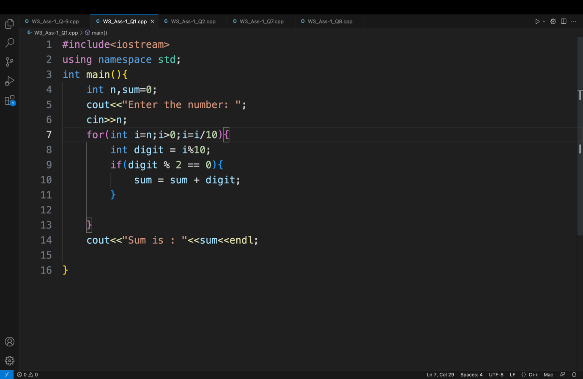

Q6.

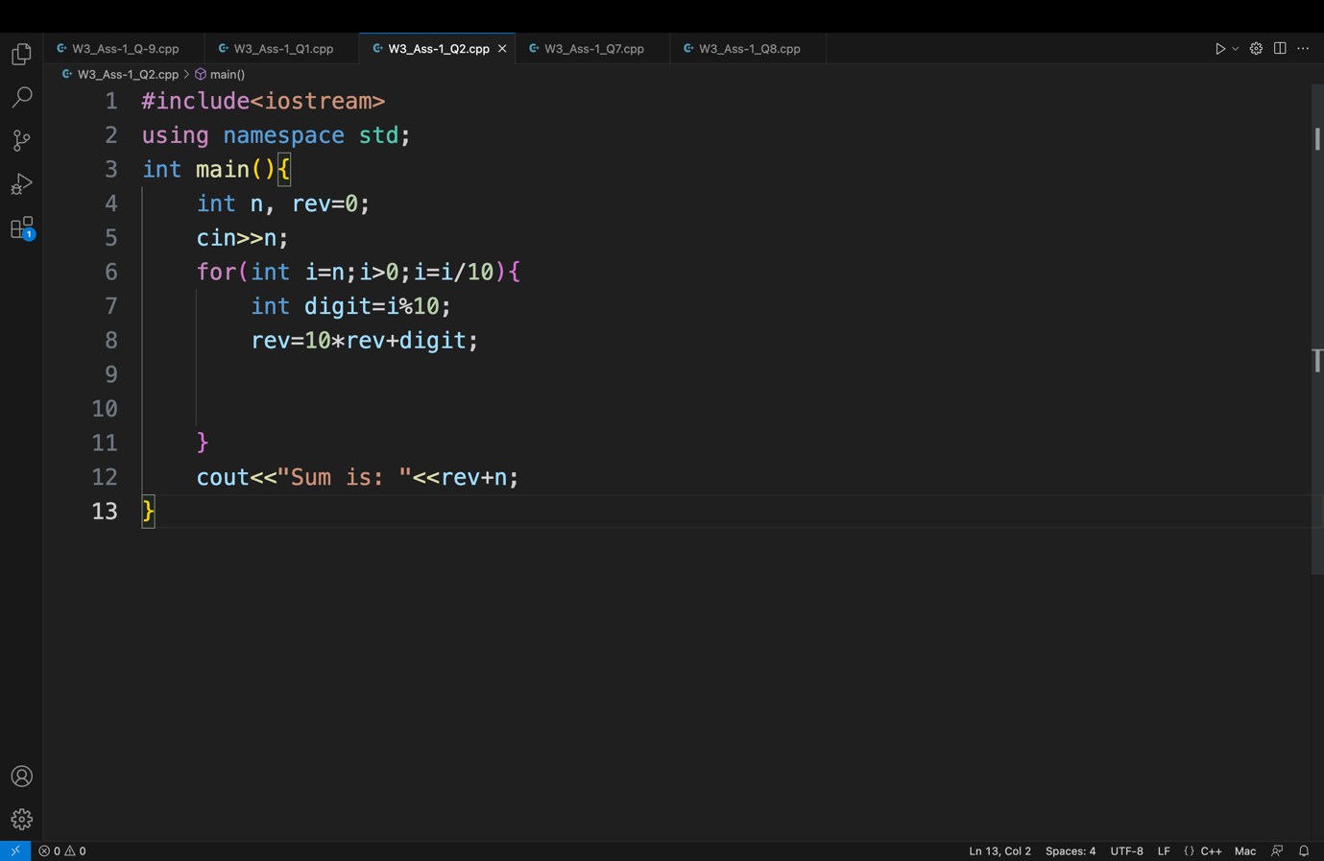

Q7.

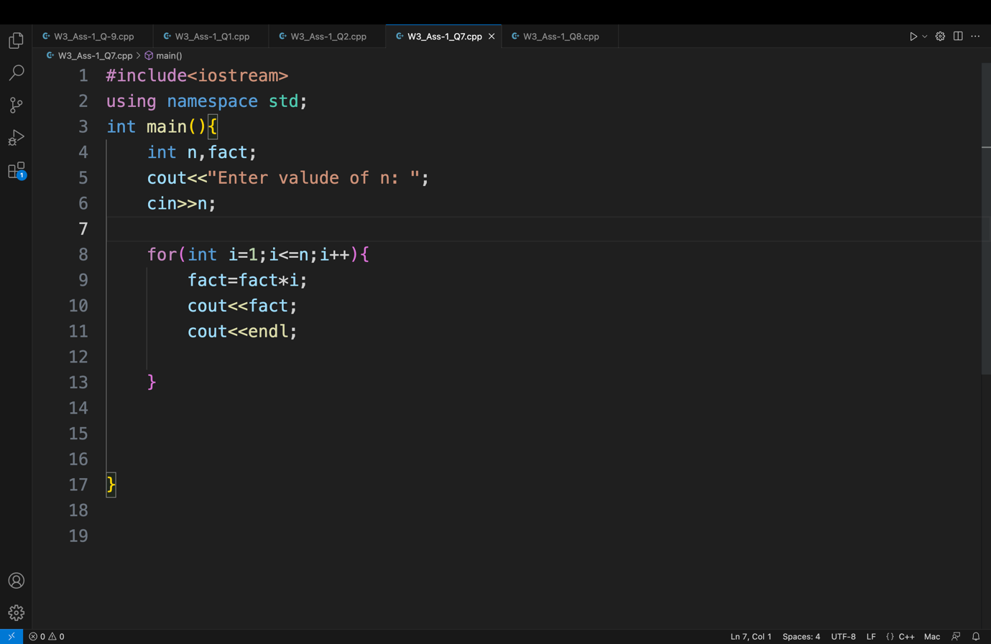

Q8.

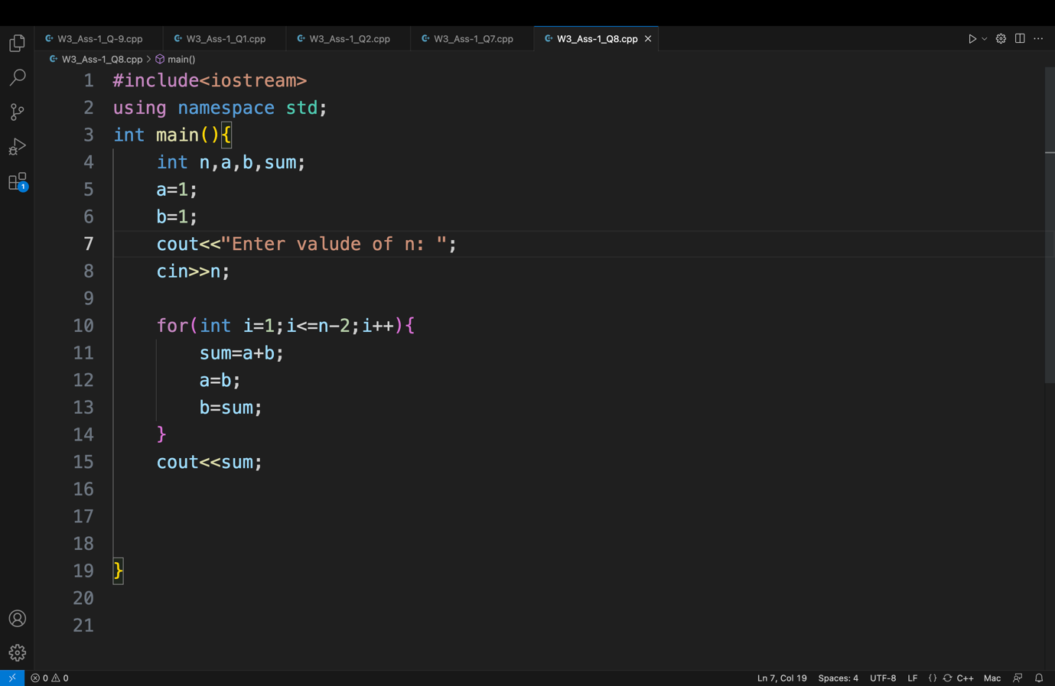

Q9.